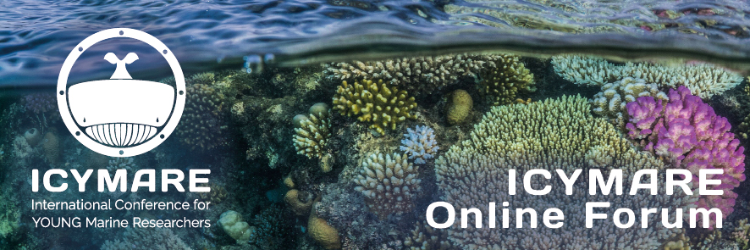
Abstract submission form for the
ICYMARE Online Forum
Please fill in this form for the submission of your abstract for the ICYMARE Online Forum. Please submit your abstract together with a recent CV to: online-forum@icymare.com.
Please do not change the file format of this document!
Upon submission you declare that you are aware that in case of acceptance:
- your abstract, incl. your mail address may be archived on the ICYMARE homepage
- your talk will be streamed online for interested people via Big Blue Button
- your talk will be recorded and may be published on the ICYMARE homepage
- the open discussion after all talks will be recorded and published on the ICYMARE homepage

Please tick the following box if you wish that a recording your talk should not be made available on the ICYMARE homepage:
☐Please do not publish the recording of my talk on the ICYMARE homepage

Please choose the date and, thus, the topic of the Online Forum in which you want to present a talk:
Date

Title:
Please enter the title of your presentation here

Authors:
Please fill in all authors contributing to the work you want to present and tick the boxes for corresponding author and yourself as the presenting author. Use the + on the right for adding more arrays.

First Name Last Name ^{Affiliations (e.g. 1,2)} ☐Corresponding Author☐ Presenting Author

Affiliations:
Please fill in all affiliations of the contributing authors according to the numbers stated above. Use the + for adding more arrays.

^{no.} Affiliation (Institution, City, Country)

Please provide the email address of the corresponding author as well as the presenting author
Corresponding author: example.example@example.com
Presenting author: example.example@example.com

Keywords:
Please provide max. 5 keywords about your presentation topic. Terms should not be already part the title, but should also not be too general.
Keyword 1; Keyword 2; Keyword 3; Keyword 4; Keyword 5

Abstract:
Please insert your abstract here. It can have 300 words at maximum. Please to not use citations, references, figures, etc.
Please enter your abstract here

