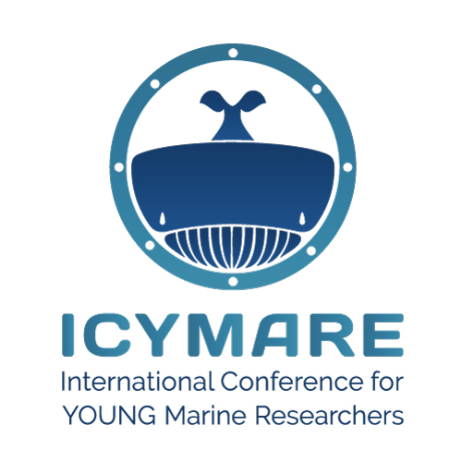**Sessions for ICYMARE 2023 OLDENBURG**

We ask every session host to fill in this form for our database. This helps us to organize the conference in an efficient way and handle all data with ease.

We kindly ask you to provide a photo of (just) yourself and sign (digitally) the declaration on page 2, confirming that we are allowed to use your photo at our homepage and social media channels to advertise your session.

Please send this form as a Word document (.docx) together with the photo via email back to us (abstract@icymare.com).

*Please enter your session title below:*

session title

*Please enter your call for abstracts on your session topic to invite presenters from all over the world (max. 100 words):*

call for abstracts

*Voluntarily indicate your gender (we want to address you the way you feel most comfortable with)*

choose your gender

*Please enter your name*

first name last name

*Please enter your email address*

example.example@example.com

*Please indicate your participation on our mandatory session host workshop by selecting one of the dates given below:*

choose your date

*Please provide us with your social media handles (“@...” or link) to enable us to tag you*

Twitter: Twitter handle Instagram: Instagram handle

Facebook: Facebook handle LinkedIn: LinkedIn handle

*main affiliation*

main affiliation

*Please provide us with the social media handles of your first affiliation to enable us to tag the institution (preferably “@...”, otherwise also “#...” is possible)*

Twitter: Twitter handle Instagram: Instagram handle

Facebook: Facebook handle LinkedIn: LinkedIn handle

others, e.g. #ICYMAREfamily

**Declaration of consent for the use of photographs**

**Between**

Naturwissenschaftlicher Verein zu Bremen von 1864

c/o Übersee-Museum Bremen

Bahnhofsplatz 13

28195 Bremen

Germany

**and**

Ms/Mr/Dr.

Last name, First name

Day of Birth

Adress

Country

hereinafter referred to as the 'Photographed Person'.

**Subject matter**

Photographic images of the Photographed Person

**Intended use:**

Publication on the Internet on the webpages <https://www.icymare.com> and <https://www.nwv-bremen.de/> as well as on other media produced in the context of the ICYMARE conference series or by the Naturwissenschaftlicher Verein zu Bremen (e.g., press releases, newspaper articles, etc.).

**Declaration:**

The undersigned declares his/her consent with the unremunerated use of the photographic images of his/her person for the purposes described above. Use of the photographic images for purposes other than those described above or for marketing via the transfer of the images to third parties is prohibited.

Location Date 

Signature (full name)