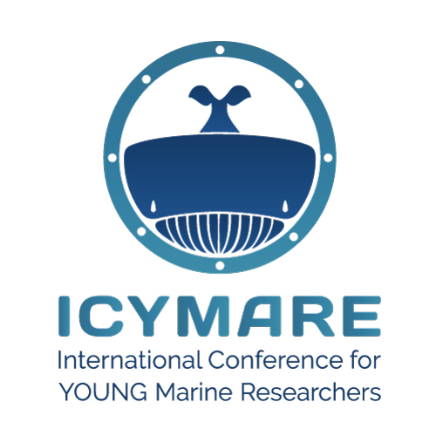
Workshop for ICYMARE 2024 Bremen

Please fill in this form for the submission of your workshop proposal for the ICYMARE conference. Once your workshop is accepted, please register as soon as possible via the ICYMARE webpage (https://www.icymare.com/), in order to secure your time slot.

Please send this form as a Word document (.docx) via email to us (workshops@icymare.com).

Please enter your name
first name last name
Please enter your email address
example.example@example.com
Please provide us with your social media handles (“@...” or link) to enable us to tag you
Twitter: Twitter handle Instagram: Instagram handle
Facebook: Facebook handle LinkedIn: LinkedIn handle
main affiliation
main affiliation
Please provide us with the social media handles of your first affiliation to enable us to tag the institution (preferably “@...”, otherwise also “#...” is possible)
Twitter: Twitter handle Instagram: Instagram handle
Facebook: Facebook handle LinkedIn: LinkedIn handle
others, e.g. #ICYMAREfamily

Workshop Title:
title of workshop
Maximum number of participants:
number of participants
Requirements:
e.g. room, laptops,
Keywords:
Please provide max. 5 keywords about your workshop topic. Terms should not be already part the title but should also not be too general.
Keyword 1, Keyword 2, Keyword 3, Keyword 4, Keyword 5
Abstract:
Please insert your abstract here. It can have 300 words at maximum. Please to not use citations, references, figures, etc.
abstract

